Nepal College of Information Technology
Unit Test
Spring 2010
Program : BE ELX/CE Time : 2 hrs
Semester : Spring (IV) FM : 70
Subject : Electronic Circuits PM : 35

- Candidates are requested to give their answer as far as practicable in their own words.
- The figure in the margin indicates the full marks
- Attempt ALL question
1. a) Why do we need multistage amplifiers? Prove that the overall current gain of Darlington pair is equal to β² for matched transistors. 2+5
b) Find the following parameters: (Take: β=100) 8

i) R_{in (stage)} | ii) R_{out (stage)} | iii) A_{V}
iv) A_{VS} | v) V_{L}
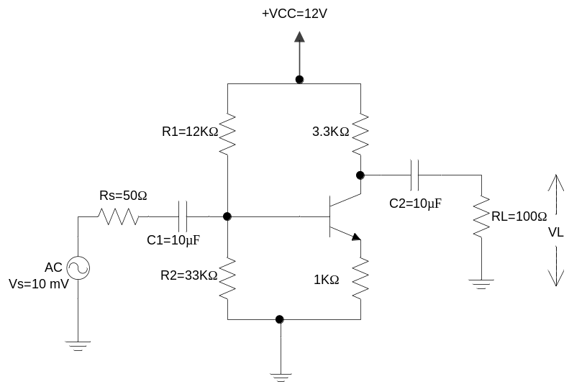
c) Find V_{L}/V_{S} in the circuit below: (β=100, r_{e}=25 Ω, r_{c}=1MΩ) 8
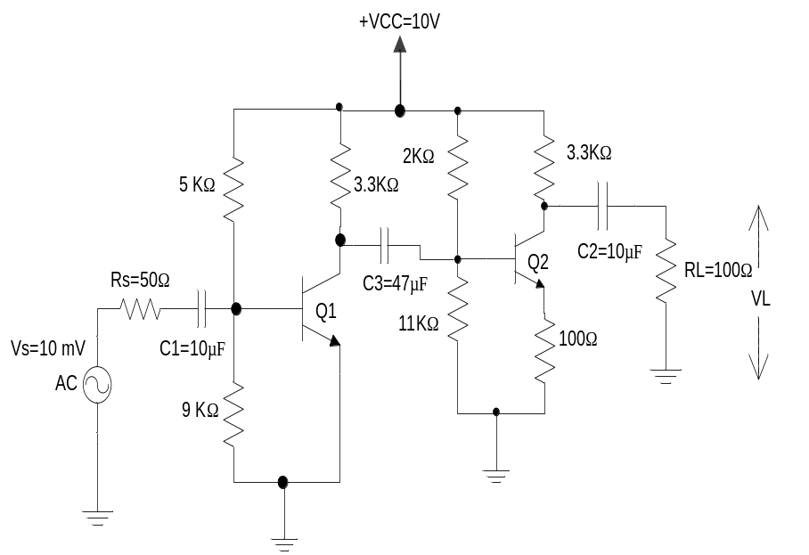
2. a) What is Miller Effect? Derive the expression for its Capacitance. 7
b) The amplifier in the circuit below has mid-band gain V_{L}/V_{S} =140. Find: 8
i) The lower cutoff frequency.
ii) Gain V_{o}/V_{in}.
- The lower cutoff frequency when C₂ is changed to 50 µF.
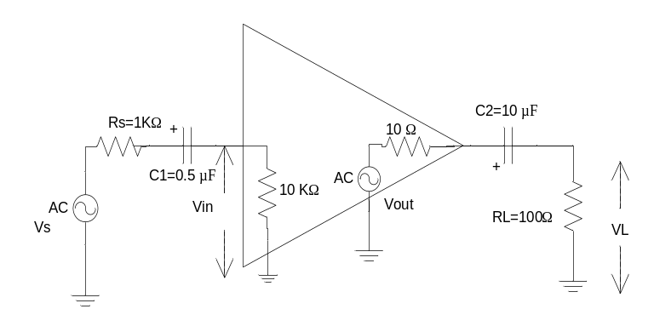
c) Describe the effect of bypass capacitor on low frequency response. 5
3. a) What is cross over distortion? How can we eliminate it? Describe the operation of transformer coupled class-B push pull amplifiers. 2+5
b) The class-A amplifier shown in the figure below is biased at V_{CE} (peak) = 10 V. The output voltage is maximum possible voltage without distortion. Find: 8
i) The power from dc supply
ii) The power delivered to the load
- Efficiency
- Collector efficiency
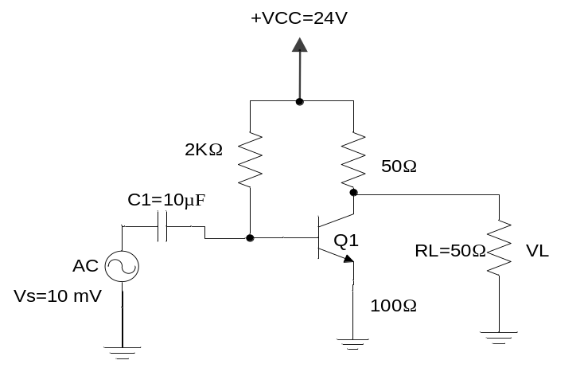
4. a) Describe the effect of negative feedback in gain and Bandwidth. How does negative feedback helps to reduce the noise, explain. 2+5
b) An amplifier with voltage gain of 50 dB uses 1/10 of its output in negative feedback. Calculate the gain with feedback in dB. 5

